Arc-Ghost Dance Shirts and Dresses

**The Role of Ghost Shirts & Ghost Dance Dresses**

*by James Mooney*

NOTE: It is now believed that the Sioux were one of the few tribes that associated Ghost Shirts and Ghost Dance Dresses with war, and most tribes wore them for purely peaceful purposes in conjunction with the Ghost Dance ceremony. However, the following essay by James Mooney published in 1896 helped to shape popular understanding of these garments and is therefore an important historical document.

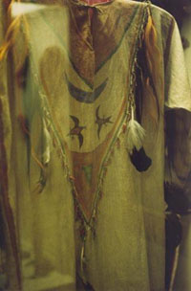The most noted thing connected with the Ghost dance among the Sioux is the “ghost shirt” which was worn by all adherents of the doctrine—men, women, and children alike. During the dance it was worn as an outside garment, but was said to be worn at other times under the ordinary dress. Although the shape, fringing, and feather adornment were practically the same in every case, considerable variation existed in regard to the painting, the designs on some being very simple, while the others were fairly covered with representatives of sun, moon, stars, the sacred things of their mythology, and the visions of the trance. In some cases the fringe or other portions were painted with the sacred red paint of the messiah. The shirt was firmly believed to be impenetrable to bullets or weapons of any sort. When one of the women shot in the Wounded Knee massacre was approached as she lay in the church and told that she must let them remove her ghost shirt in order the better to get at her wound, she replied: “Yes; take it off. They told me a bullet would not go through. Now I don’t want it any more.”

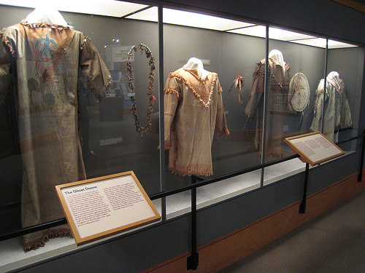

The protective idea in connection with the ghost shirt does not seem to be aboriginal. The Indian warrior habitually went into battle naked above the waist. His protecting “medicine” was a feather, a tiny bag of some sacred powder, the claw of an animal, the head of a bird, or some other small object which could be readily twisted into his hair or hidden between the covers of his shield without attracting attention. Its virtue depended entirely on the ceremony of the consecration and not on size or texture. The war paint had the same magic power of protection. To cover the body in battle was not in accordance with Indian usage, which demanded that the warrior should be as free and unencumbered in movement as possible. The so-called “war shirt” was worn chiefly in ceremonial dress parades and only rarely on the warpath.

Dreams are but incoherent combination of waking ideas, and there is a hint of recollection even in the wildest visions of sleep. The ghost shirt may easily have been an inspiration from a trance, while the trance vision itself was the result of ideas from previous observation or report. The author is strongly inclined to the opinion that the idea of an invulnerable sacred garment is not original with the Indians, but, like several other important points pertaining to the Ghost-dance doctrine, is a practical adaptation by them of ideas derived from contact with some sectarian body among the whites. 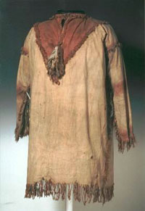It may have been suggested by the “endowment robe” of the Mormons, a seamless garment of white muslin adorned with symbolic figures, which is worn by their initiates as the most sacred badge of their faith, and by many of the believers is supposed to render the wearer invulnerable. The Mormons have always manifested a particular interest in the Indians, whom they regard as the Lamanites of their sacred writings, and hence have made special efforts for their evangelization, with the result that a considerable number of the neighboring tribes of Ute, Paiute, Bannock, and Shoshoni have been received into the Mormon church and invested with the endowment robe. The Shoshoni and northern Arapaho occupy the same reservation in Wyoming, and anything which concerns one tribe is more or less talked of by the other. As the Sioux, Cheyenne, and other eastern tribes make frequent visits to the Arapaho, and as these Arapaho have been the great apostles of the Ghost dance, it is easy to see how an idea borrowed by the Shoshoni from the Mormons could find its way through the Arapaho first to the Sioux and Cheyenne and afterward to more remote tribes. Wovoka himself expressly disclaimed any responsibility for the ghost shirt, and whites and Indians alike agreed that it formed no part of the dance costume in Mason valley. When I first when among the Cheyenne and neighboring tribes of Oklahoma in January, 1891, the ghost shirt had not yet reached them. Soon afterward the first one was brought down from the Sioux country by a Cheyenne named White Buffalo, who had been a Carlisle student, but the Arapaho and Cheyenne, after debating the matter, refused to allow it to be worn in the dance, on the ground that the doctrine of the Ghost dance was one of peace, whereas the Sioux had made the ghost shirt an auxiliary of war. In consequence of this decision such shirts have never been worn by the dancers among the southern tribes. Instead they wear in the dance their finest shirts and dresses of buckskin, covered with painted and beaded figures from the Ghost-dance mythology and the visions of the trance.

**The Glasgow Ghost Shirt**

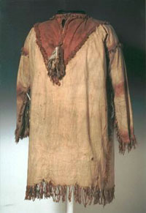The so-called "Glasgow Ghost Shirt" was discovered by a Cherokee Indian named John Earl during a visit to a museum in Glasgow, Scotland. The shirt had been in the Kelvingrove Museum there since 1892 when George C. Crager, a member of the Buffalo Bill Wild West Show, sold it and several other items to the curator. This shirt is believed to have been taken from one of the 146 victims of the massacre at Wounded Knee in 1890. It is pierced in several places with bullet holes, and slight brown stains still mar the torn cloth. This shirt has been returned to the Lakota people, and replaced by a new Ghost Dance Shirt made in 1998 by Marcella Le Beau, greatgrandaughter of one of the survivors of the massacre at Wounded Knee.

The bloodstains on the plain cotton shirt are barely visible anymore. The holes created by the fatal bullets almost look as if they could have occured naturally with the passage of time. The Raven, Owl and Eagle feathers hanging from the neck of the off-white tunic are tattered and ragged.

A Ghost Shirt was a shirt or dress worn by someone participating in a Ghost Dance. The shirt was usually made of white cotton cloth, although a few were made of leather. Blue, yellow and red pigment was used to paint stars, moons, birds and other designs on the shirt. Feathers, especially those of birds sacred to the wearer, and buffalo fur often adorned the shirts as well. Each wearer decorated his or her shirt with symbols from personal visions or items of power.

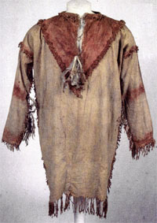While many tribes wore the ghost shirts and took part in the dance, only the Lakota believed that the clothing would protect them from the bullets of the white man. One of the songs sung at the Lakota ceremonies celebrated the special protection of the Ghost Shirt: *"Verily, I have given you my strength, Says the Father, says the Father. The shirt will cause you to live, Says the Father, says the Father."* Kicking Bear, a Miniconjou Teton, made a pilgrimage to Nevada to learn about this new "religion". He returned to his people and together with Short Bull, another Miniconjou mystic, gave the religion a unique interpretation, choosing to disregard Wovoka's anti-violence and emphasizing the eventual elimination of the white people. Short Bull told his followers that if surrounded by white soldiers, those wearing the ghost shirts should sing a certain song to make the soldiers fall down dead. Short Bull continued by stating *"you must know this, that all the soldiers and that race will be dead."*

Ghost Dance shirts are objects of power to the wearer, and sacred to the tribes. While some shirts are displayed in museums, this practice isn't one of universal acceptance among the families of those who participated in the Ghost Dance.

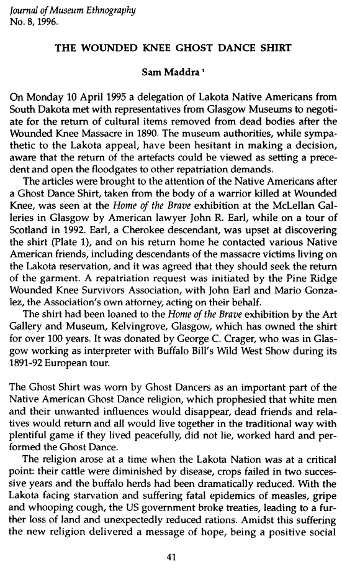

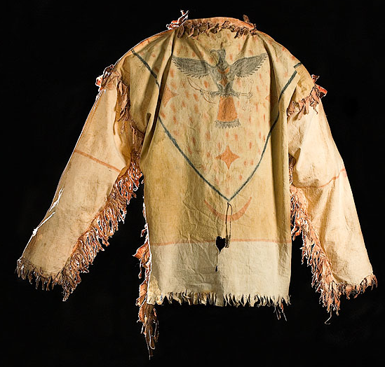

* 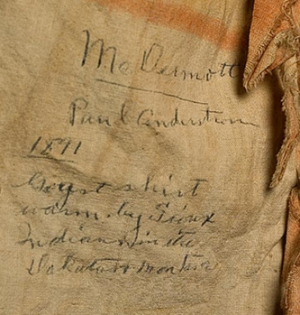Item Category: -
* Source: [Cowan's Auctions](http://www.worthpoint.com/source/cowans-auctions)
* Sold Date: Jun 05,2008
* Channel: Auction House

muslin, painted with blue, yellow, and orange pigments depicting a thunderbird with bow and arrows in talons, flanked by stars and a crescent moon; written in ink along lower hem McDermott/ Paul Anderstrom/ 1891/ Gogst [sic] shirt/ warn by Sioux/ Indians in the/ Dakotas and Montana, length 27.5" x chest 50". AUCTIONEER'S NOTE: Paul Burton Anderson was born in 1948 and is the son of Catherine Rose McDermott, the daughter of Sergeant William J. McDermott.

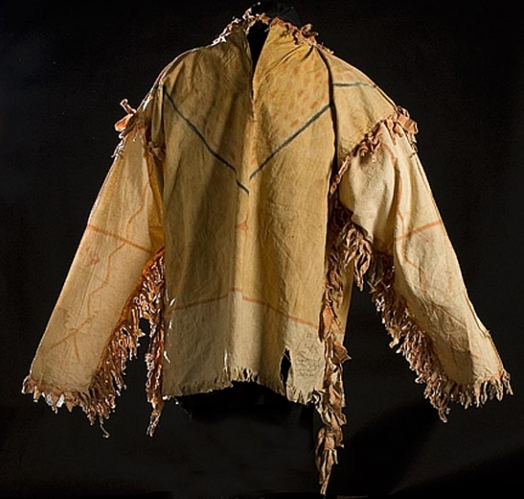

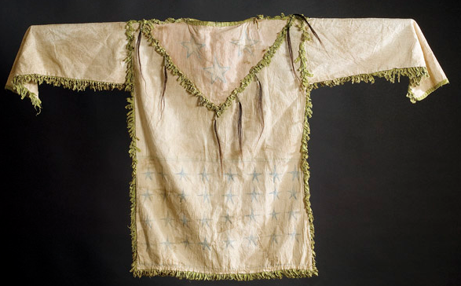

### CENTRAL PLAINS PAINTED GHOST DANCE SHIRT,

* Sold for:

or

* to see what it's worth.
* Item Category: -
* Source: [Cowan's Auctions](http://www.worthpoint.com/source/cowans-auctions)
* Sold Date: Sep 07,2005
* Channel: Auction House

thread-sewn of muslin, with bib and side seams decorated with short green fringe. Three blue, outlined five-pointed stars decorate one side of bib, while a red star with `power rays` is painted on opposite. Drops of hair hang from bib and 32 blue stars are painted on lower half of shirt. Mirrored on opposite side is same number of red crosses. Neck lined with calico, length 33` x chest 46`.

### 

### 

### War Shirt / Ghost Dance Shirt

* Sold for:

or

* to see what it's worth.
* Item Category: -
* Source: [eBay](http://www.worthpoint.com/source/ebay)
* Sold Date: Nov 25,2007
* Channel: Online Auction

This auction is for a Beautifully Painted and Decorated Reservation Period Ghost Dance or War Shirt. It measures about 55" wide and 40" long with fringe. Has multiple fethers which I've had looked at and they are dyed turkey fethers. Shirt looks very old to me an should date to at least Reservation Period, if not pre 1900. Stand in photo does not come with shirt. As always if you need additional pictures or close ups, just ask. Thanks for looking and happy bidding.

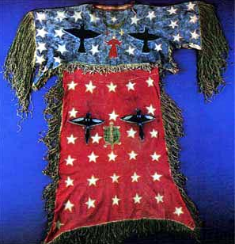

Sioux Ghost Dance Dress

Many [Sioux](http://quatr.us/northamerica/after1500/history/sioux.htm) people, especially women, were dancing the Ghost Dance over and over until they collapsed. The United States soldiers were very nervous about all this dancing. Sitting Bull, a chief of the Sioux, wanted people to stop dancing, but another chief, Kicking Bear, told him that if people wore their Ghost Shirts while they were dancing no bullets could hit them. So people did keep dancing in their Ghost Shirts. The United States soldiers came to arrest Sitting Bull to try to stop the dancing, and Sitting Bull was shot to death in December of 1890.

====================================================================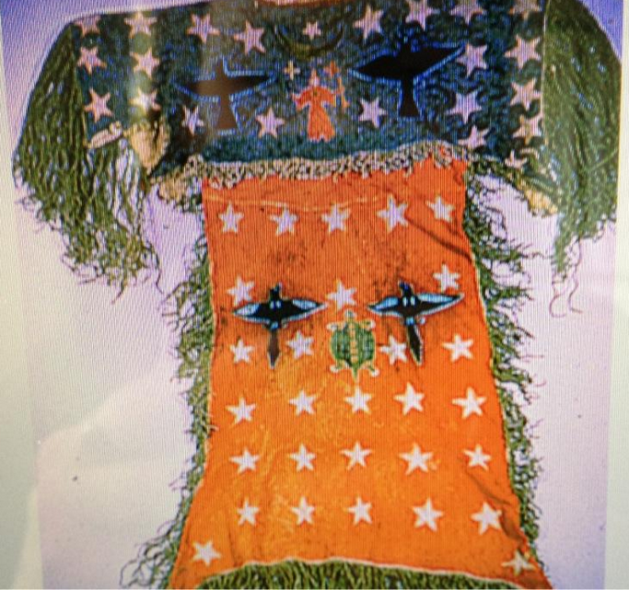

Arapaho

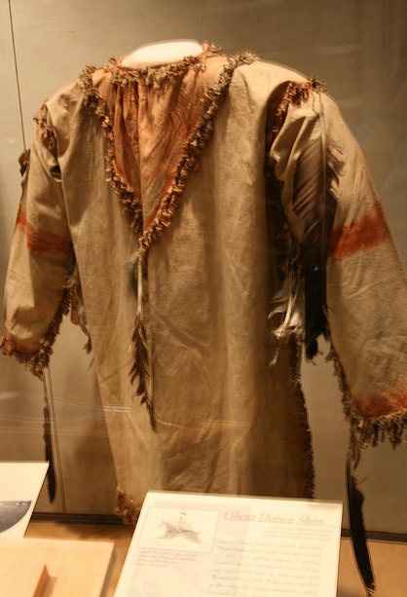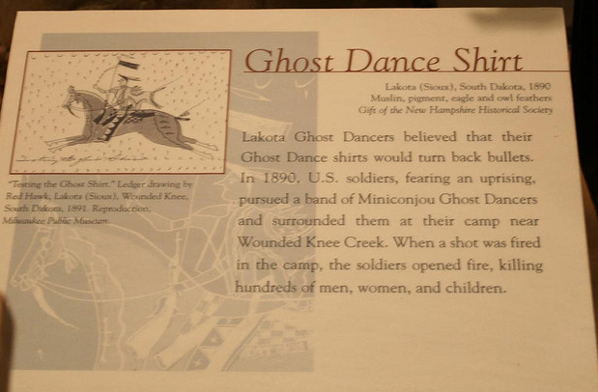

[Buffalo Bill Center of the West](https://www.flickr.com/photos/47203757@N06/) · [Galleries](https://www.flickr.com/photos/47203757@N06/galleries/) Plains Indian Museum

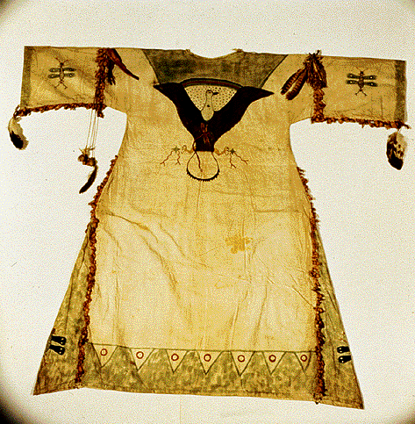

**8.7 A Lakota Ghost Dancing shirt, believed to protect its wearer from bullets.**

*(National Museum of the American Indian)*

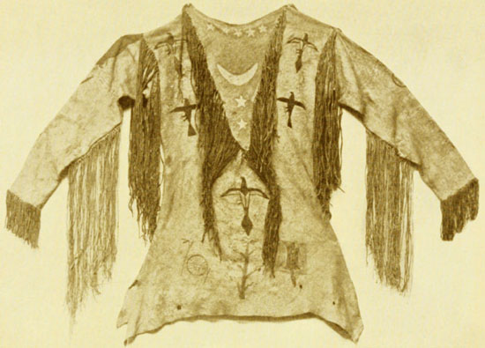

**Arapaho Ghost Shirt**

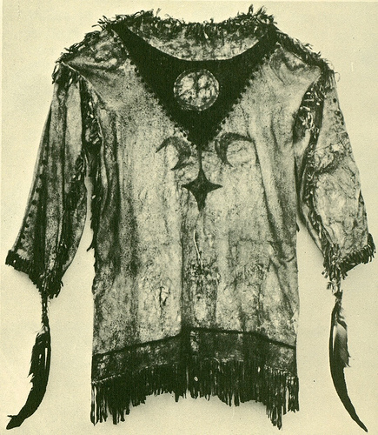

**Arapaho Ghost Shirt**

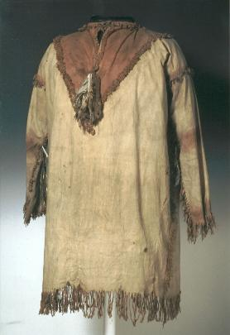

**Lakota Ghost Shirt (Glasgow)**

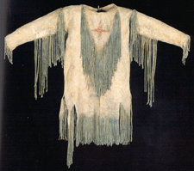

**Kiowa Ghost Shirt**

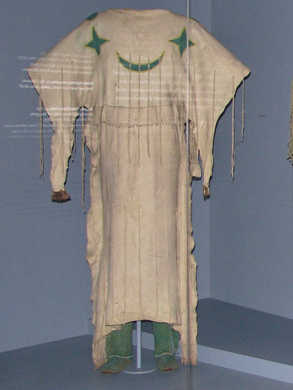

**Kiowa Ghost Dance Dress**

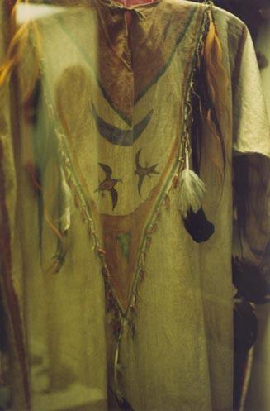

**Ghost Shirt**

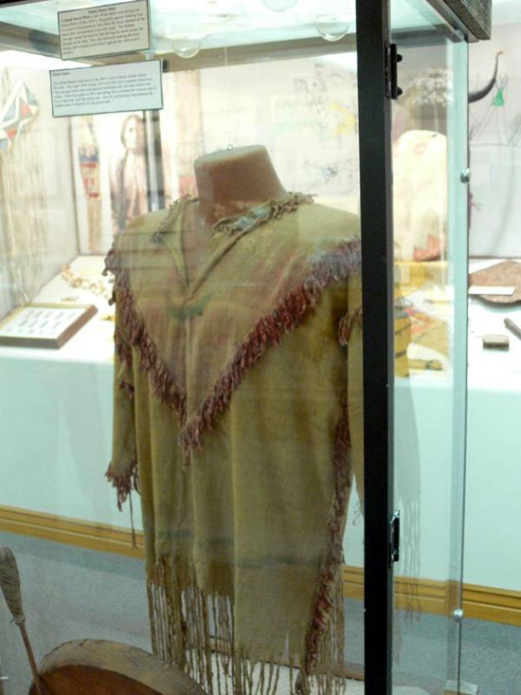

**Ghost Shirt**

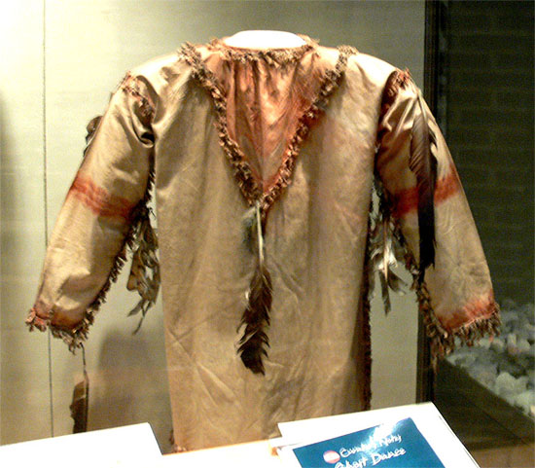

**Ghost Shirt**

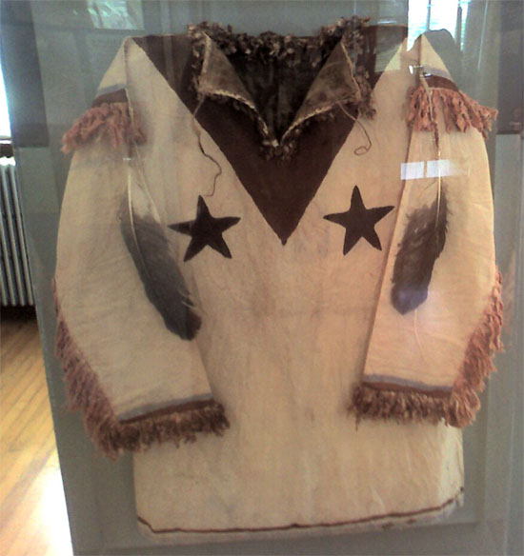

**Ghost Shirt**

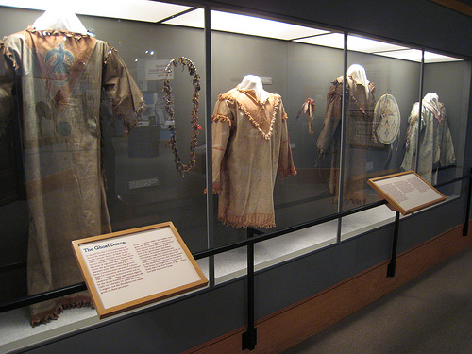

**Four Ghost Shirts**

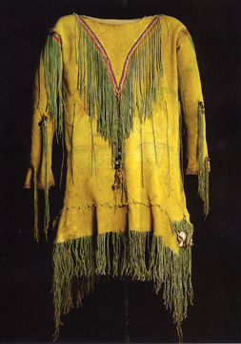

**Plains Ghost Shirt**

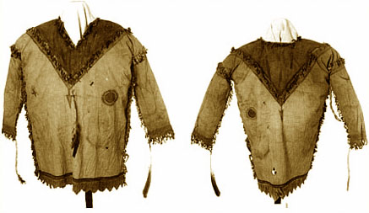

**Lakota Ghost Shirt (W.H. Over Museum)**

The above Ghost Shirt from the W.H. Over Museum has the painted V-shaped neck, fringes, and feathers typical of Lakota shirts.

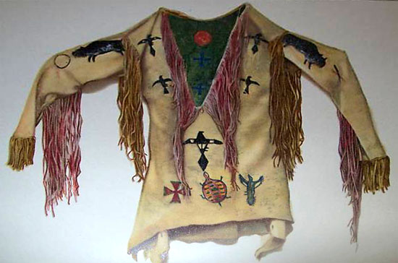

**Arapaho Ghost Shirt**

**The Role of Ghost Shirts & Ghost Dance Dresses**

*by James Mooney*

NOTE: It is now believed that the Sioux were one of the few tribes that associated Ghost Shirts and Ghost Dance Dresses with war, and most tribes wore them for purely peaceful purposes in conjunction with the Ghost Dance ceremony. However, the following essay by James Mooney published in 1896 helped to shape popular understanding of these garments and is therefore an important historical document.

The most noted thing connected with the Ghost dance among the Sioux is the “ghost shirt” which was worn by all adherents of the doctrine—men, women, and children alike. During the dance it was worn as an outside garment, but was said to be worn at other times under the ordinary dress. Although the shape, fringing, and feather adornment were practically the same in every case, considerable variation existed in regard to the painting, the designs on some being very simple, while the others were fairly covered with representatives of sun, moon, stars, the sacred things of their mythology, and the visions of the trance. In some cases the fringe or other portions were painted with the sacred red paint of the messiah. The shirt was firmly believed to be impenetrable to bullets or weapons of any sort. When one of the women shot in the Wounded Knee massacre was approached as she lay in the church and told that she must let them remove her ghost shirt in order the better to get at her wound, she replied: “Yes; take it off. They told me a bullet would not go through. Now I don’t want it any more.”

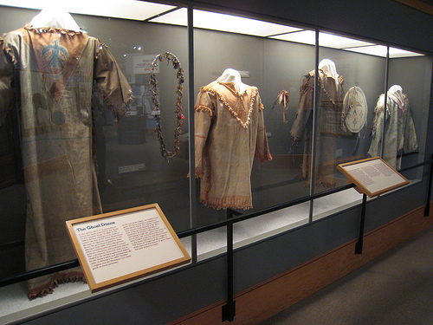

The protective idea in connection with the ghost shirt does not seem to be aboriginal. The Indian warrior habitually went into battle naked above the waist. His protecting “medicine” was a feather, a tiny bag of some sacred powder, the claw of an animal, the head of a bird, or some other small object which could be readily twisted into his hair or hidden between the covers of his shield without attracting attention. Its virtue depended entirely on the ceremony of the consecration and not on size or texture. The war paint had the same magic power of protection. To cover the body in battle was not in accordance with Indian usage, which demanded that the warrior should be as free and unencumbered in movement as possible. The so-called “war shirt” was worn chiefly in ceremonial dress parades and only rarely on the warpath.

Dreams are but incoherent combination of waking ideas, and there is a hint of recollection even in the wildest visions of sleep. The ghost shirt may easily have been an inspiration from a trance, while the trance vision itself was the result of ideas from previous observation or report. The author is strongly inclined to the opinion that the idea of an invulnerable sacred garment is not original with the Indians, but, like several other important points pertaining to the Ghost-dance doctrine, is a practical adaptation by them of ideas derived from contact with some sectarian body among the whites. It may have been suggested by the “endowment robe” of the Mormons, a seamless garment of white muslin adorned with symbolic figures, which is worn by their initiates as the most sacred badge of their faith, and by many of the believers is supposed to render the wearer invulnerable. The Mormons have always manifested a particular interest in the Indians, whom they regard as the Lamanites of their sacred writings, and hence have made special efforts for their evangelization, with the result that a considerable number of the neighboring tribes of Ute, Paiute, Bannock, and Shoshoni have been received into the Mormon church and invested with the endowment robe. The Shoshoni and northern Arapaho occupy the same reservation in Wyoming, and anything which concerns one tribe is more or less talked of by the other. As the Sioux, Cheyenne, and other eastern tribes make frequent visits to the Arapaho, and as these Arapaho have been the great apostles of the Ghost dance, it is easy to see how an idea borrowed by the Shoshoni from the Mormons could find its way through the Arapaho first to the Sioux and Cheyenne and afterward to more remote tribes. Wovoka himself expressly disclaimed any responsibility for the ghost shirt, and whites and Indians alike agreed that it formed no part of the dance costume in Mason valley. When I first when among the Cheyenne and neighboring tribes of Oklahoma in January, 1891, the ghost shirt had not yet reached them. Soon afterward the first one was brought down from the Sioux country by a Cheyenne named White Buffalo, who had been a Carlisle student, but the Arapaho and Cheyenne, after debating the matter, refused to allow it to be worn in the dance, on the ground that the doctrine of the Ghost dance was one of peace, whereas the Sioux had made the ghost shirt an auxiliary of war. In consequence of this decision such shirts have never been worn by the dancers among the southern tribes. Instead they wear in the dance their finest shirts and dresses of buckskin, covered with painted and beaded figures from the Ghost-dance mythology and the visions of the trance.